Key elements of HTML where I had a significant developmental role

I was responsible for creating all the pages you see before you go into the game this includes the start screen, the vaccine select screen, the leaderboard, credits and accessibility option pages. You will notice on these pages that there is a video that loops in the background of these pages which I done by using the video tag in HTML, I also used the form tag and dropdown menus in the accessibility options page which allows the user to apply their choices. I also made use of the table tag to display the vaccines in the vaccine select page. I also used the audio tag in every page within the game which has the typing effect.

The following are screenshots of code for the pages where I had significant developmental role:

startScreen.html

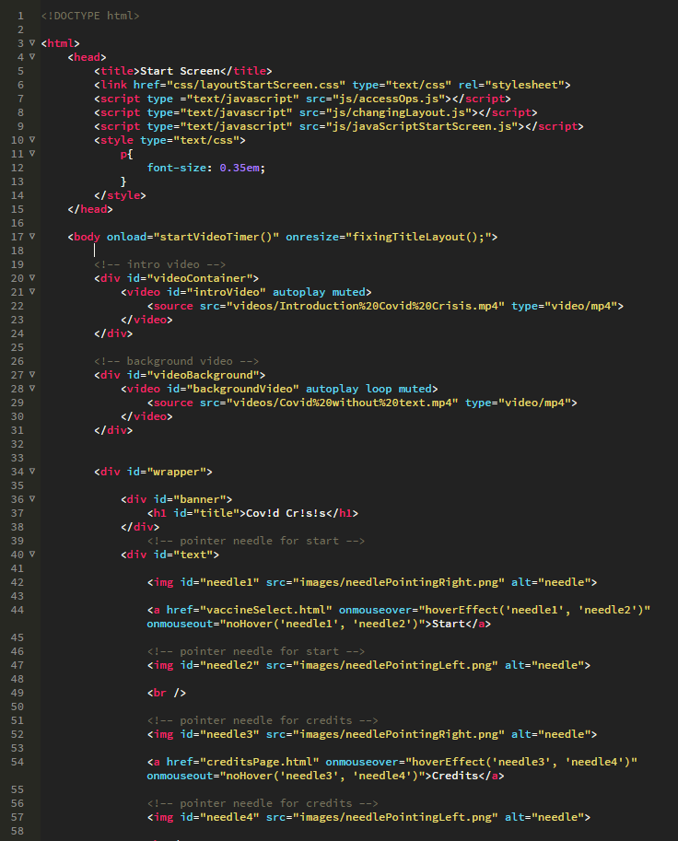

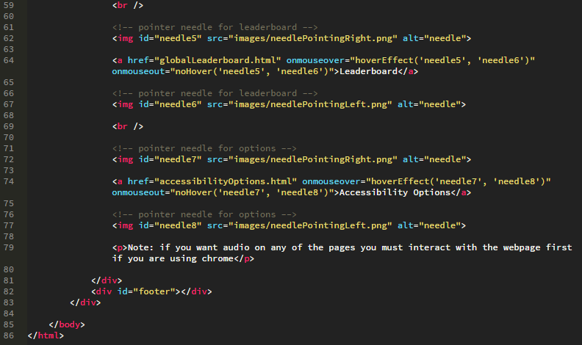

vaccineSelect.html

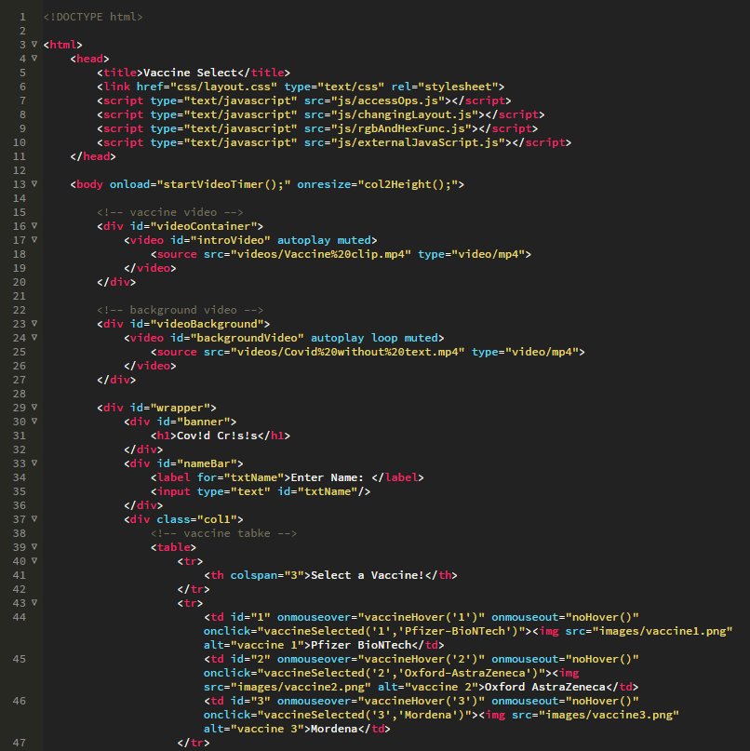

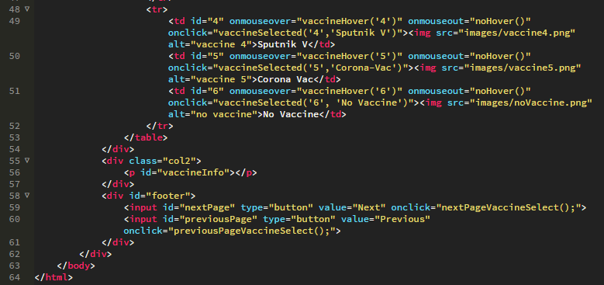

globalLeaderboard.html

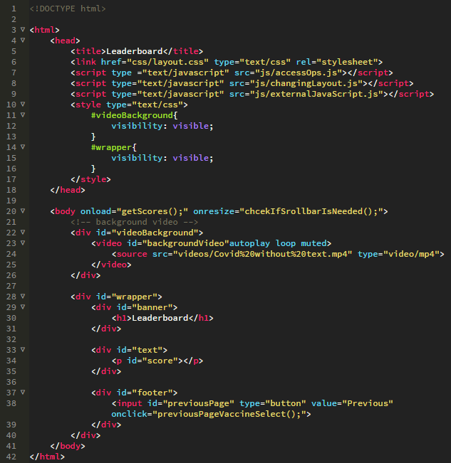

creditsPage.html

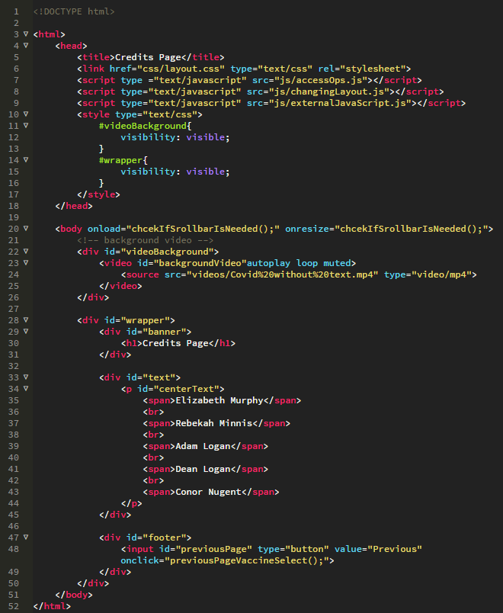

accessibilityOptions.html

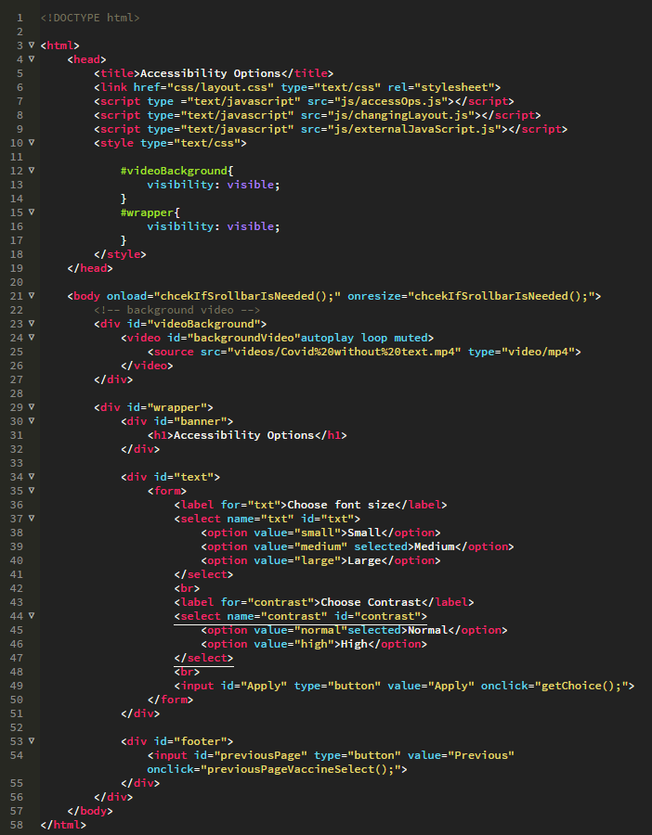

Key elements of CSS where I had a significant developmental role

I had significant developmental role in the pages at the beginning of the game, the same pages as the ones listed in the HTML section above. I used CSS in these pages to create a suitable layout for all the starting pages for user experience.

I then used the CSS rule keyframes in multiple places for different animation effects, the first place you will see some animation is whenever the intro video finishes playing it will fade out and then the content of the starting screen will fade in, I did this by changing the opacity of the images gradually to 0 for fade off and then to 1 for fade on. You will also see whenever you hover over something on the starting screen that there are 2 needles that flash which are pointing towards the option you are currently hovering over, this is also done by changing the opacity of the images however instead of it going from 0 to 1 it will go from 0 to 0.5 then back to 1, I also used the flashing animation whenever a user selects a vaccine.

Another place where I used keyframes is the border animation for whenever the user hovers over one of the vaccines. This animation also makes use of the pseudo elements before and after to allow for each of the borders to be drawn (top to left and right to bottom), this allows the user to clearly see which one of the vaccines they are currently hovering over.

I also used media queries within CSS to change the layout of the start page and vaccine select page whenever the user makes the page a certain size. I done this to make the pages easier to read for the user if the resolution is at a smaller size.

The following are screenshots of code for the pages where I had significant developmental role:

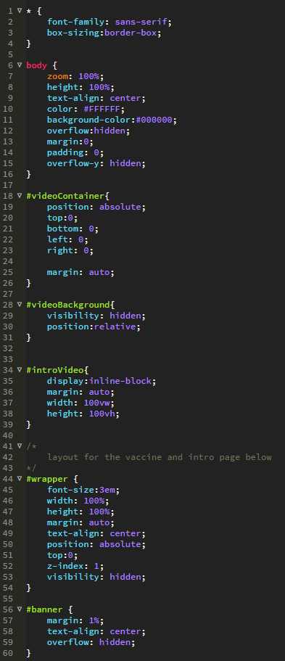layoutStartScreen.css

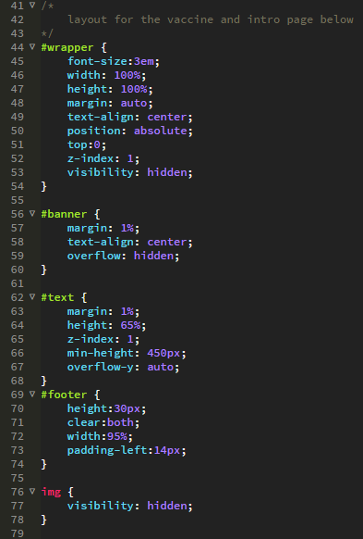

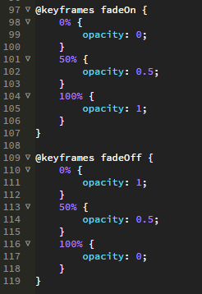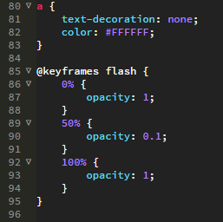

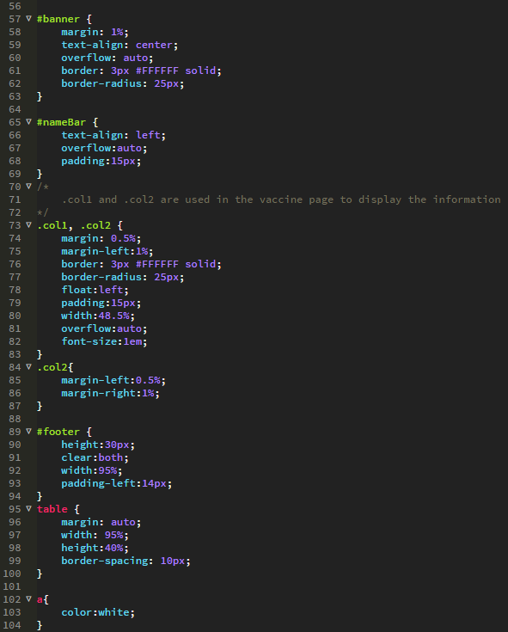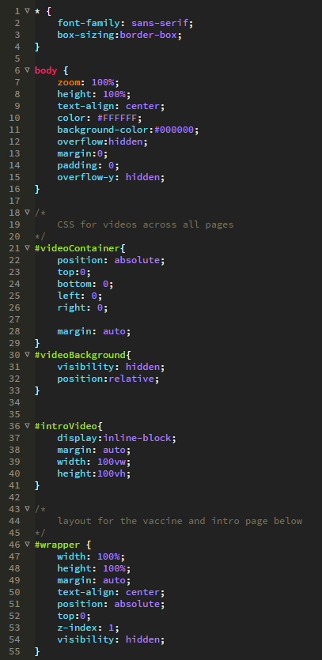Layout.css

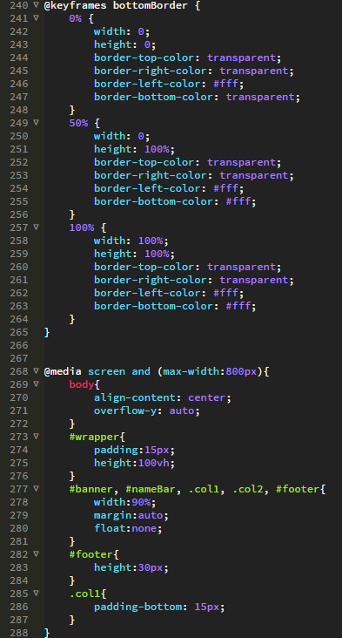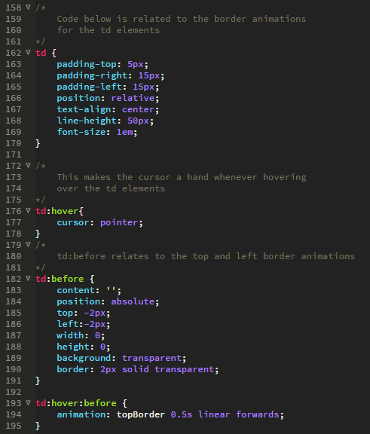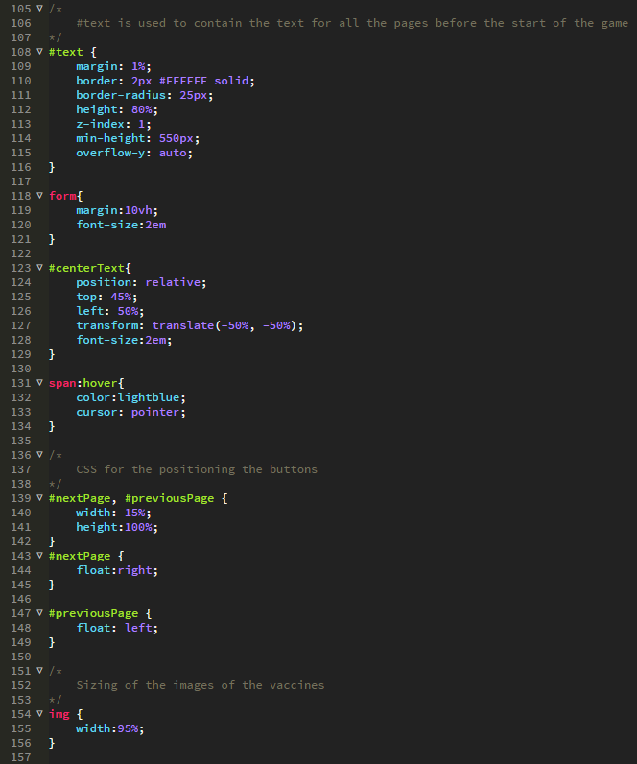

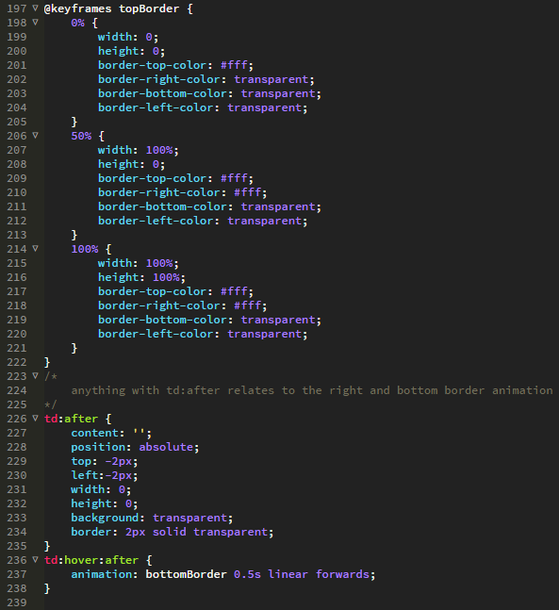

Key elements of JavaScript where I had a significant developmental role

Once again, my main responsibilities where round the starting pages however when it came to the JavaSript I was also in charge of creating a typing effect for the text that appears throughout the game, creating a timing feature for each page so the user can see a breakdown of their run and a leaderboard function which will store the users’ previous runs.

For the typing effect I used JavaScript timed events (specifically setInerval) and JavaScript DOM methods to make a string appear 1 letter at a time every couple milliseconds to appear as if someone is actually typing the letters themselves, I also recorded myself typing on my keyboard and made it so as the typing effect is being played the audio of me typing starts playing to add to the effect. The typing effect also has some user customisation as it uses sessionStorage to display whatever the user entered their name as throughout the game.

For the storing of the time the user takes in each individual run I done this by using JavaScript timed events and passing these values through the pages using sessionStorage to display on the final screen using JavaScript DOM methods.

Then for the leaderboard I used localStorage to store the time it took the user to play the game and the user’s name. The leaderboard is also ordered from the fastest time to the lowest time using a bubble sort algorithm. I used localStorage to ensure the data is stored even when the browser is closed.

I also used sessionStorage and DOM methods for the accessibility options allowing each page to be affected by the users choice. E.g changing the font size on every page or the contrast.

Another place which I used sessionStorage was for storing what the user entered their name as and what vaccine they selected which effects the game in the find items page.

Other places where I used JavaScript was in fixing the format of the video when the user resizes the page, displaying the necessary information whenever the user hovers over vaccines, triggering the animations whenever they are meant to play and for stopping and starting the videos when necessary.

The following are screenshots of code for the pages where I had significant developmental role:

typingEffect.js

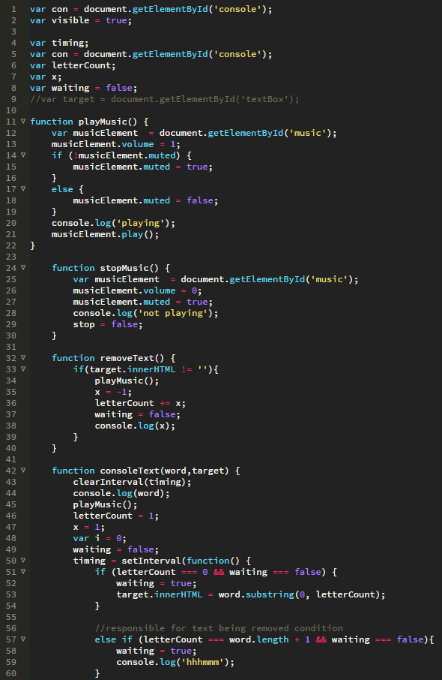

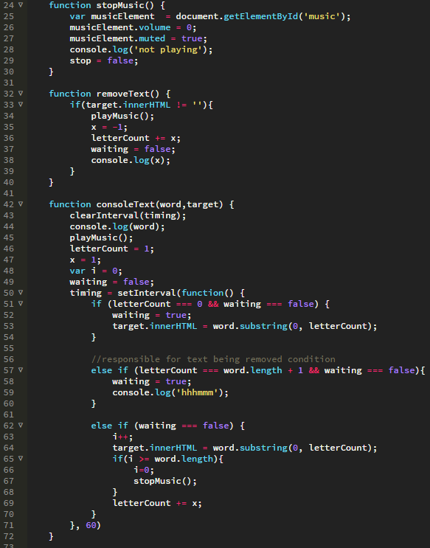

changingLayout.js

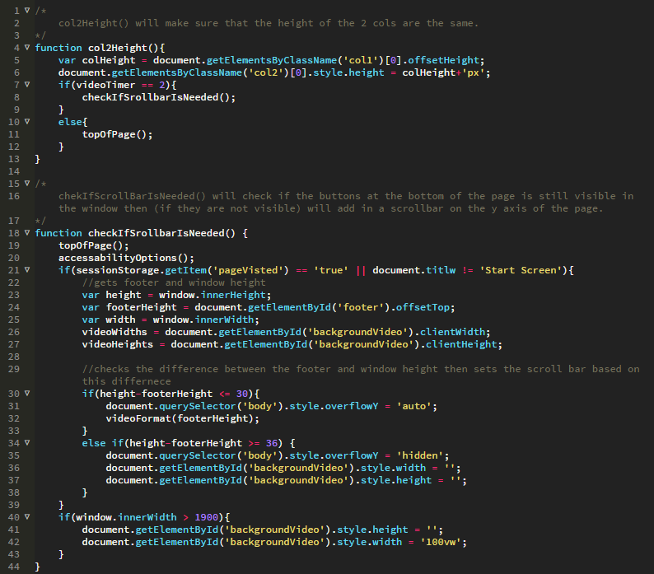

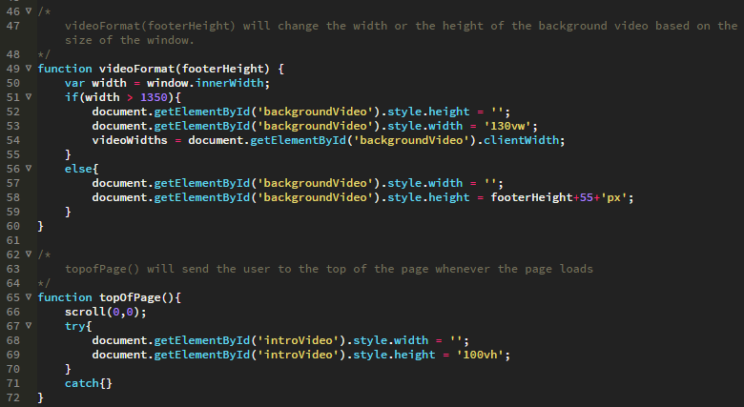

accessOps.js

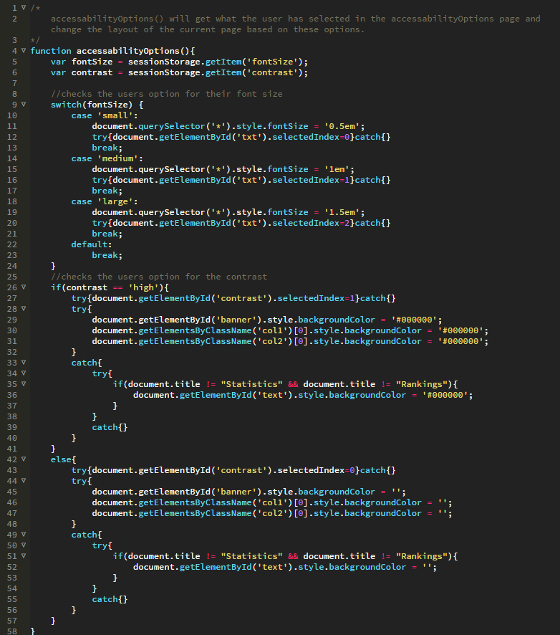

externalJavaScript.js

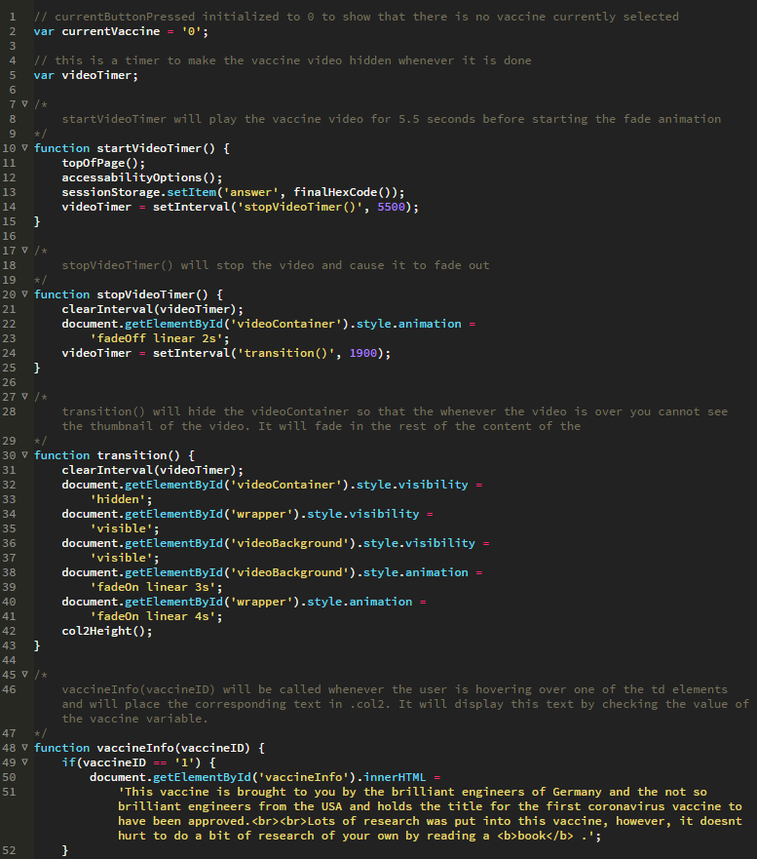

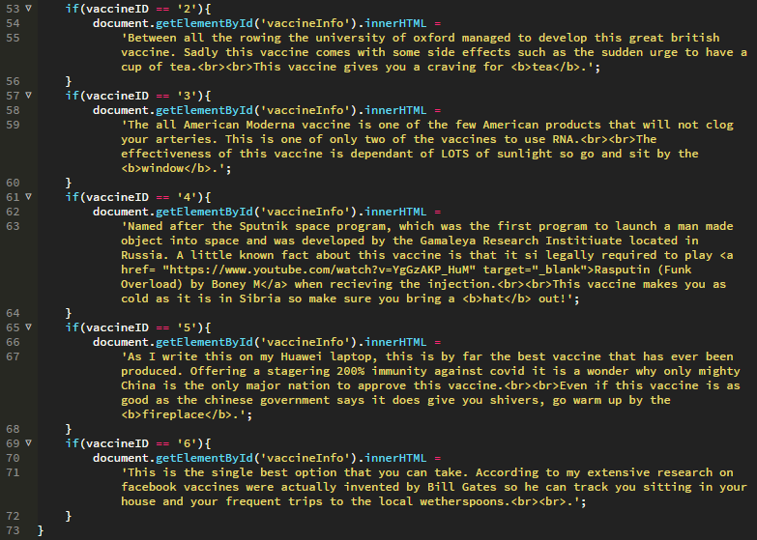

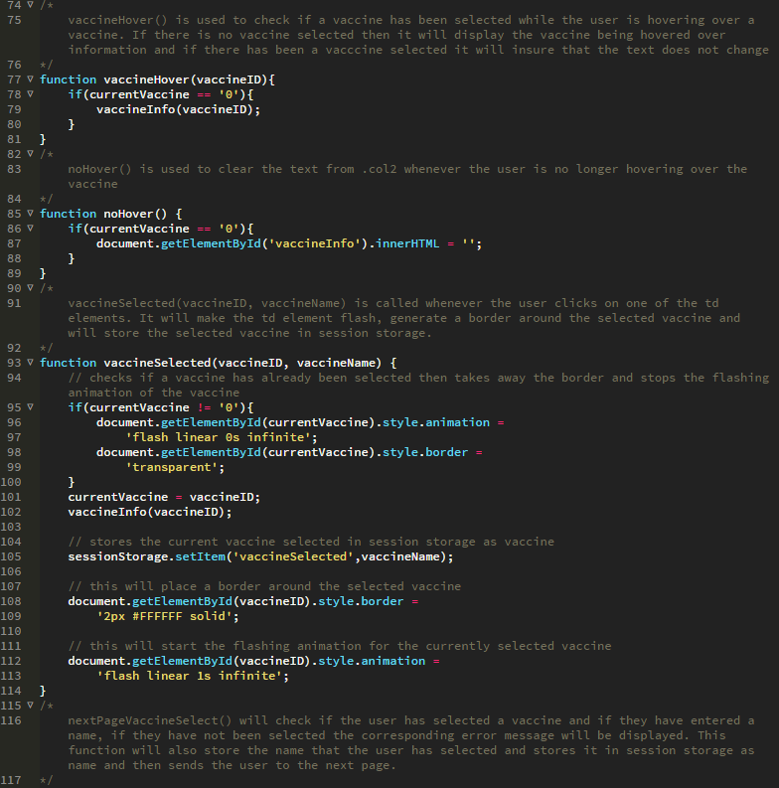

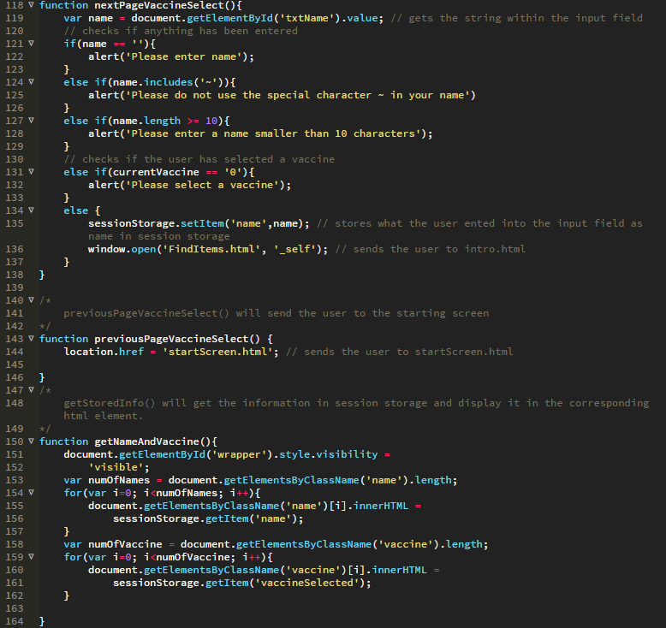

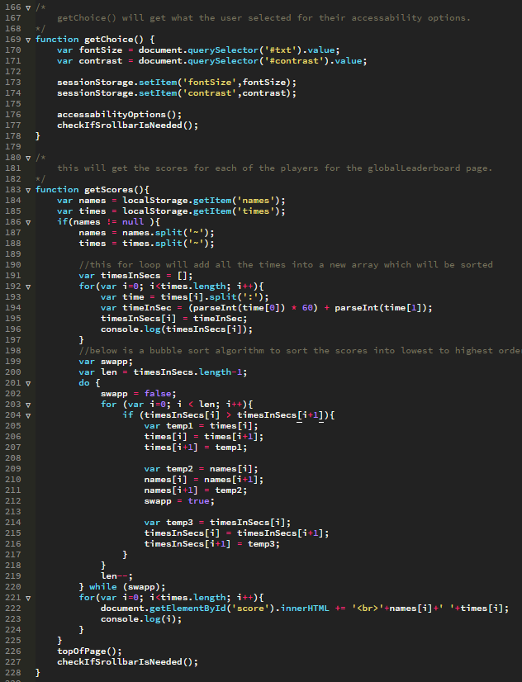

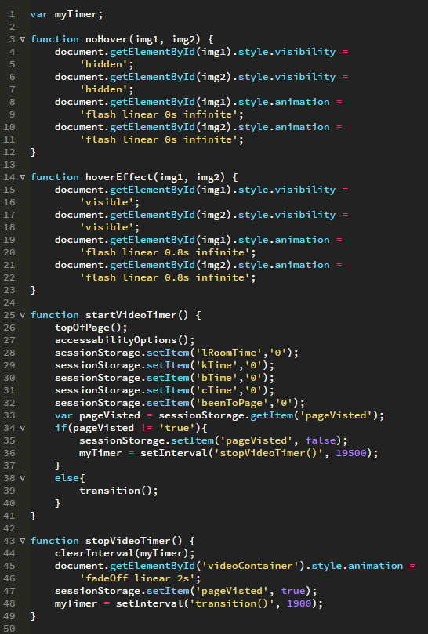javaScriptStartScreen.js



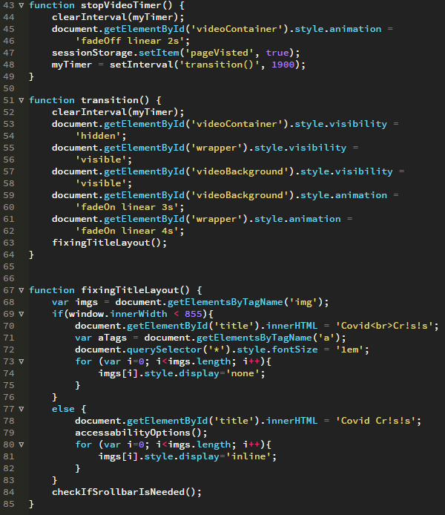

Top features of technical complexity and/or quality of user experience where I had a significant developmental role

One of the top features where I had significant developmental role would be the accessibility options as explained above in the JavaScript section, I used sessionStorage to store the choices the user selected in the dropdown menus then apply these changes to the rest of the pages.

To apply these changes in the other pages of the game I created a script which collects what the user selected on the accessibility options page and then used JavaScript DOM methods to apply the changes.

Another top feature of the game is the leaderboard and breakdown at the end of the game which used sessionStorage and localStorage. As explained before this allows the user to see how long they spent in each room so that they can improve in their next run. The leaderboard also adds replayability as it makes the user want to try harder to beat their time or their friend’s time.

The following are screenshots of all the pages where I had a significant developmental role:

startScreen.html



vaccineSelect.html

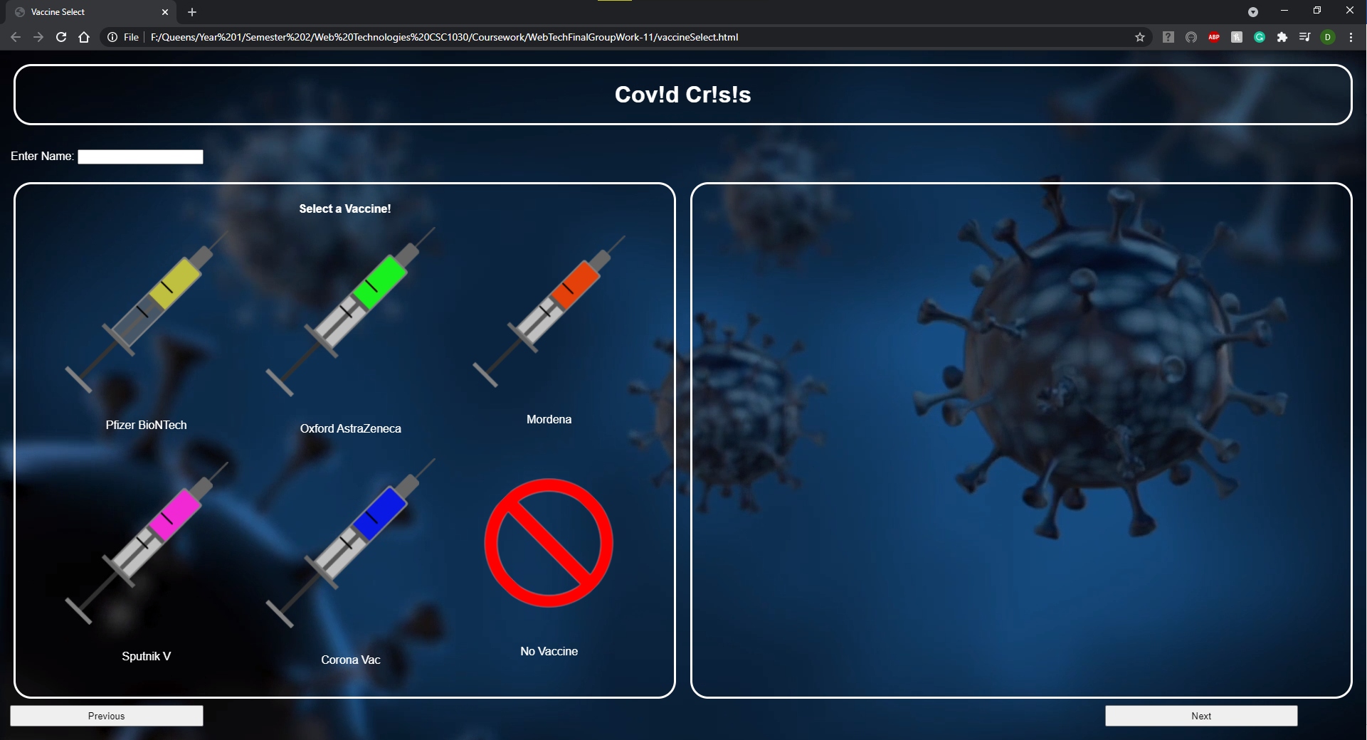

creditsPage.html

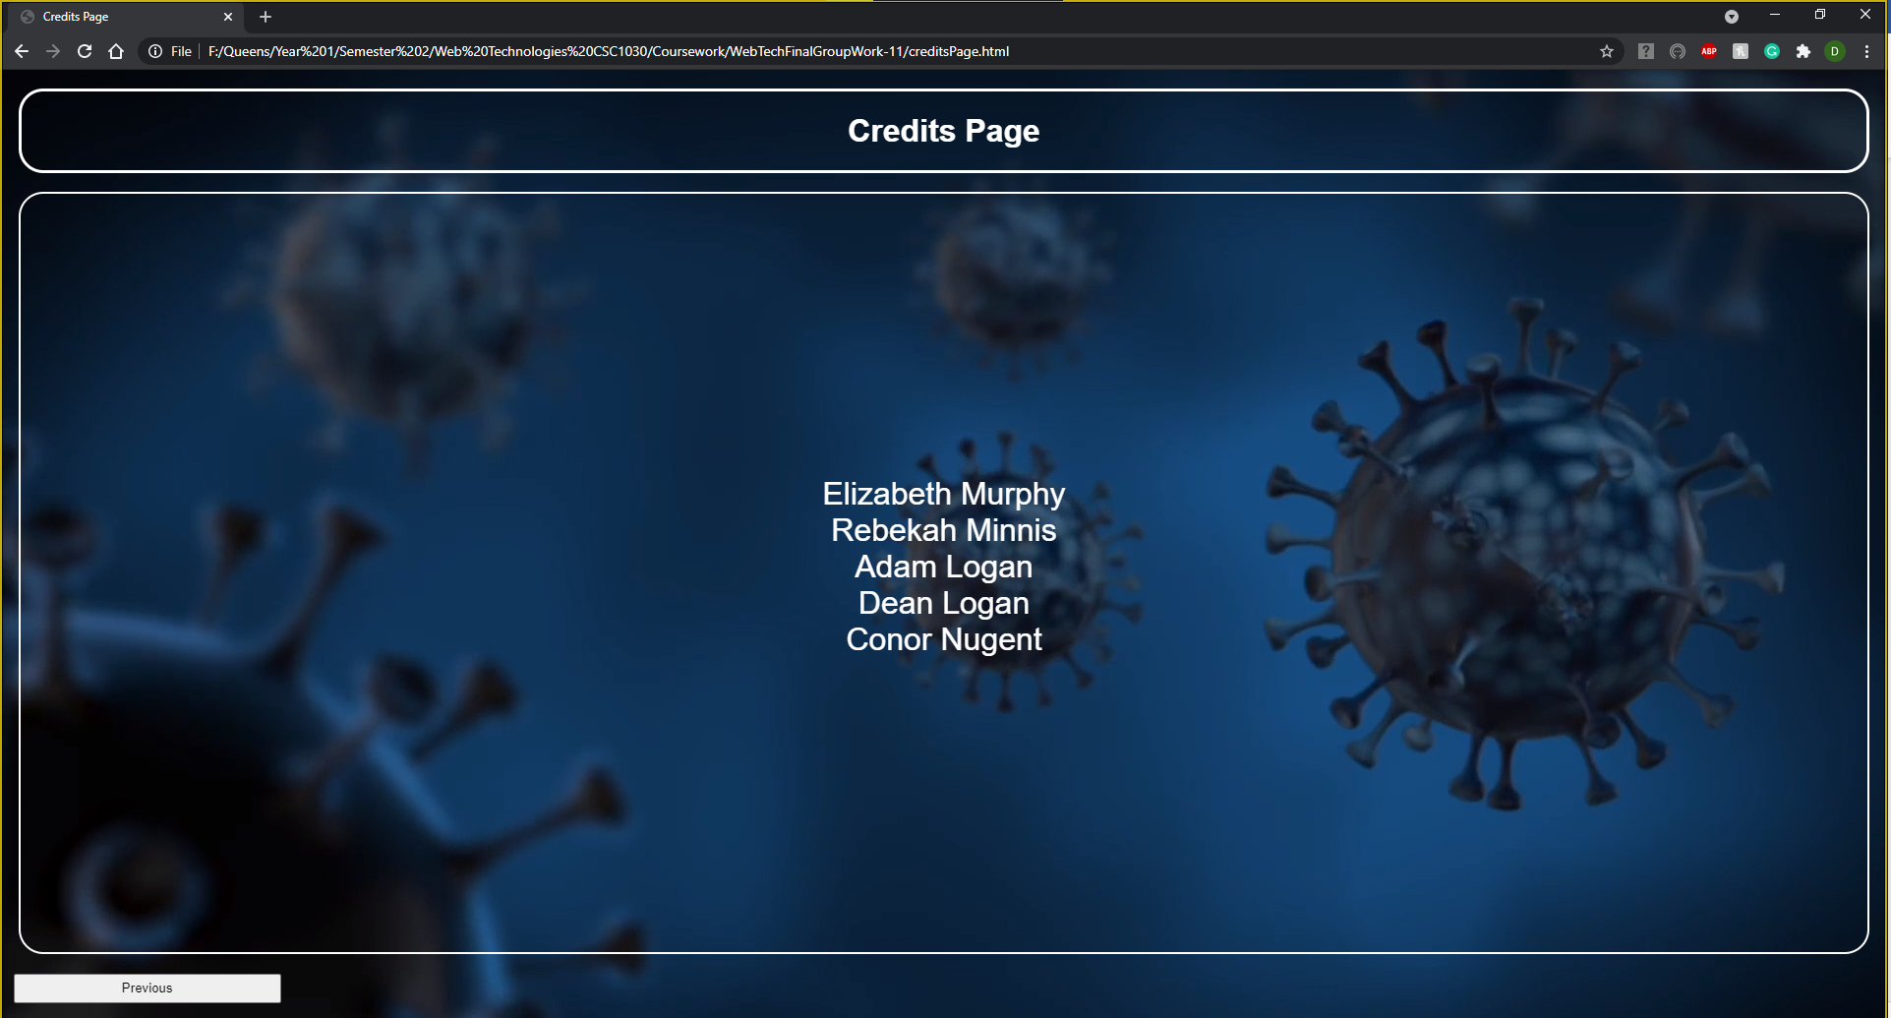

globalLeaderboard.html

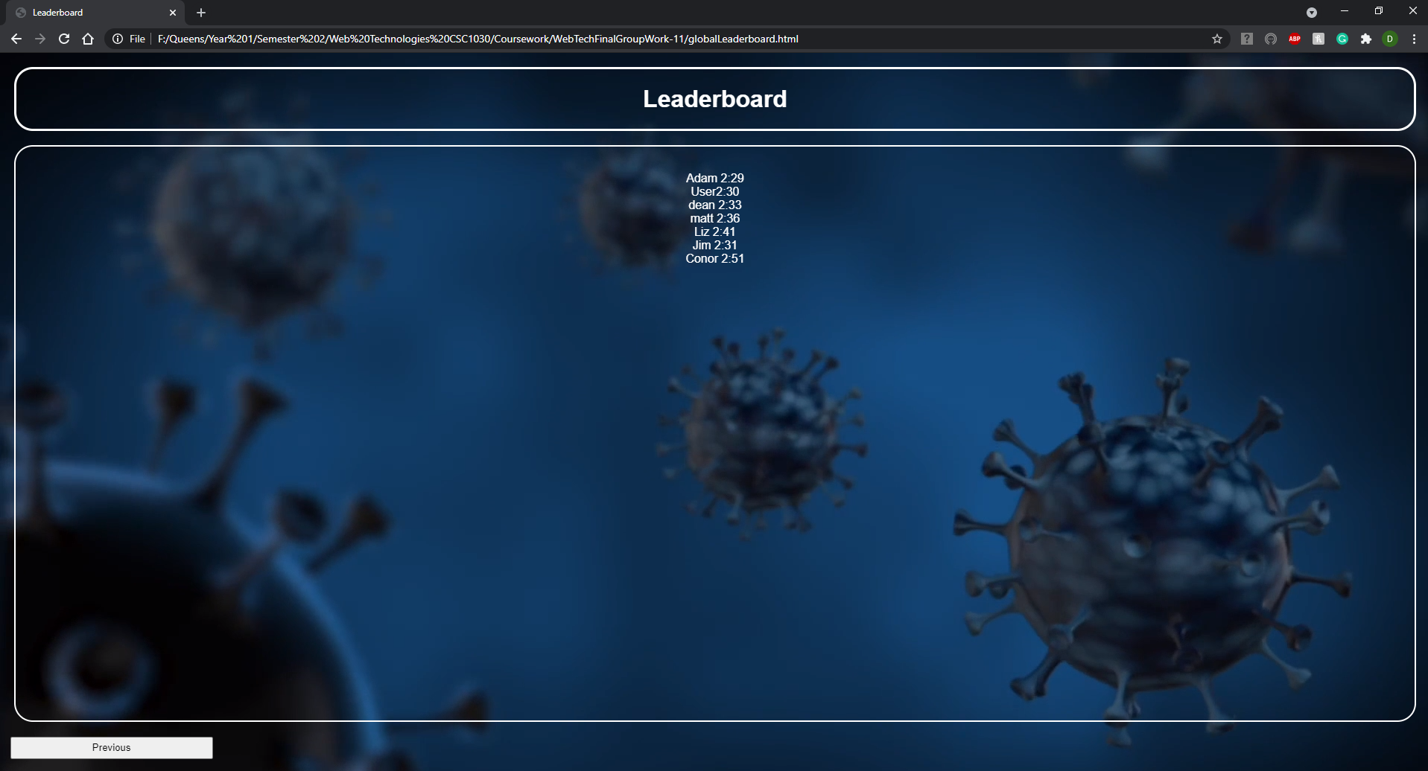

accessibilityOptions.html

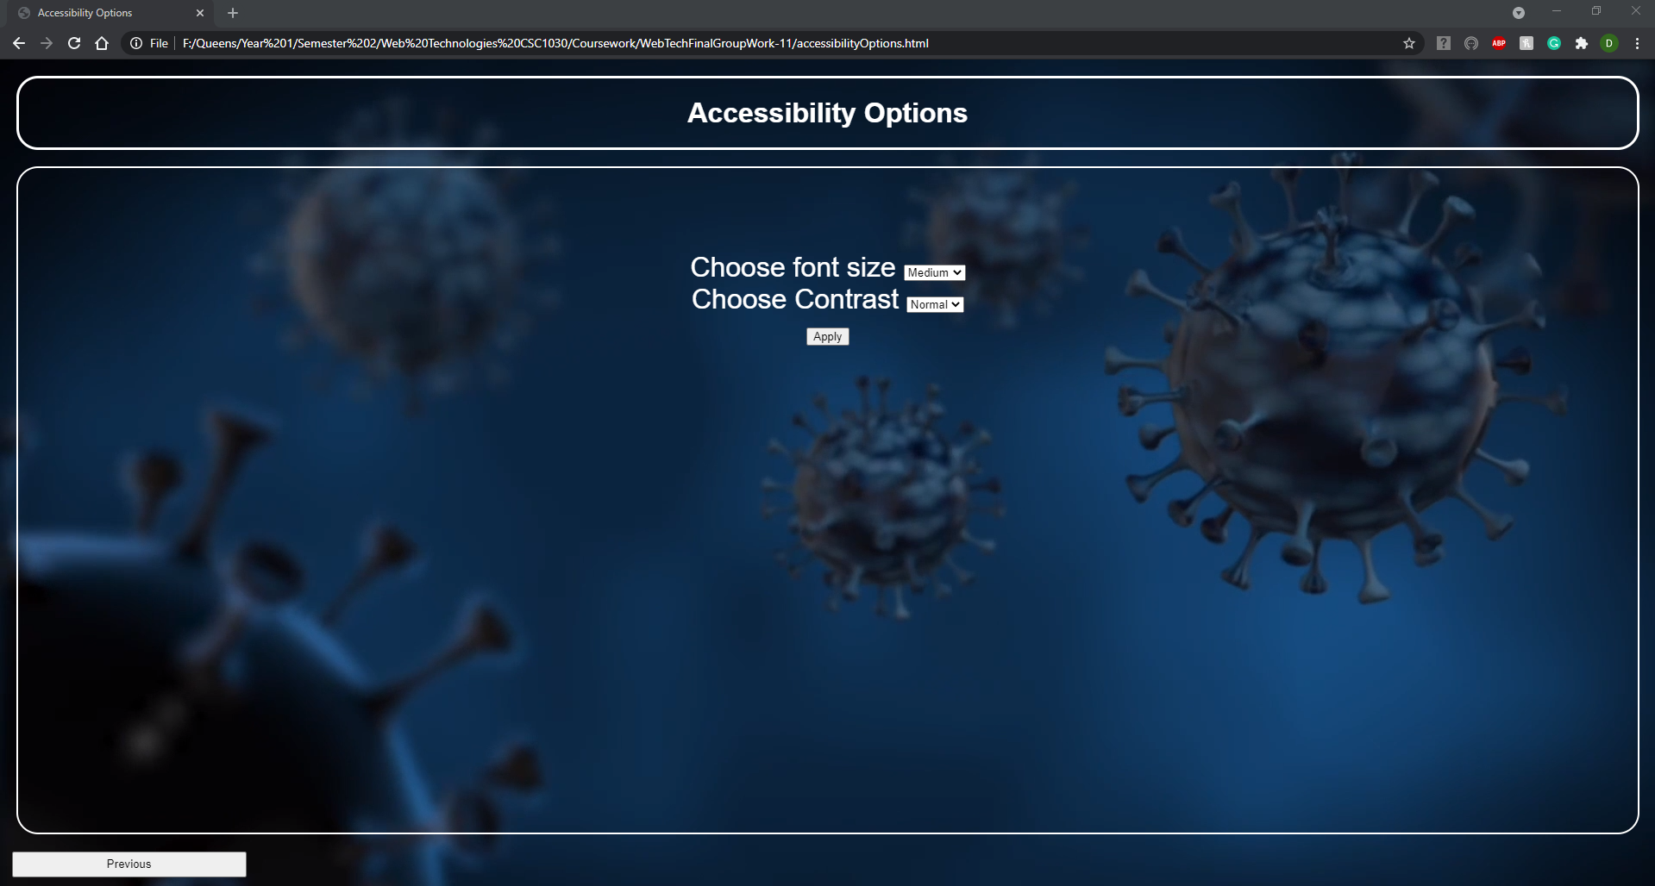

In all the pages during the game I made the typing effect which shows in the box on the left-hand side of the screen. An example is shown below.

